Activity 3.1.1 Inputs and Outputs – VEX
Introduction
Robots are similar to humans if you consider that both use inputs and outputs to sense and react to the world.

Most humans use five senses to perceive the world. Based on the input of these senses, your brain makes decisions to activate a response. Through muscle activation, the response can take many forms, including speaking, moving your hand, or running. Robots behave similarly when the world is sensed through physical touch, ambient light intensity, or distance to a solid object. The robot processor translates these inputs and activates a response by triggering a motor or light emitter.

In this activity you will use the ROBOTC software to monitor inputs and control outputs. This will allow you to test the behavior of components before writing a program and to use it as a troubleshooting tool for analyzing program performance.

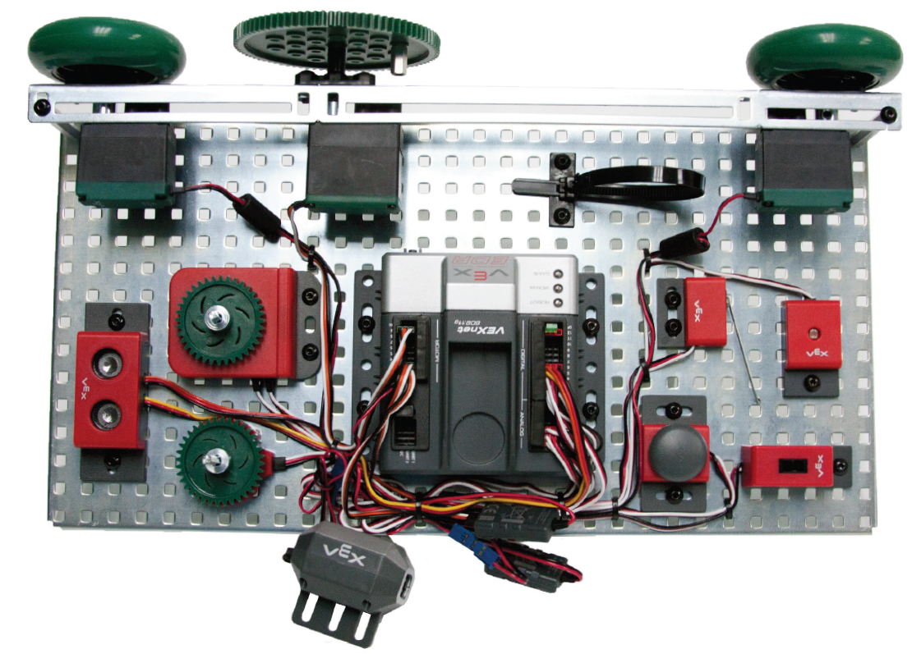

Equipment
- Computer with ROBOTC software
- PoE VEX® kit
- PoE VEX® Testbed Instructions
Procedure
- Form groups of four and acquire your group’s PoE VEX® Kit under the direction of the teacher.
- View the IntroToVEXandROBOTC.pptx presentation from slide 1 through 16.
- Within your four student group, form a two-student team known as Team A and a two-student team known as Team B.
- Construct the VEX® testbed.
  - Team A will construct the VEX® Testbed with the exception of the ultrasonic and the light sensor.
  - Team B will construct the VEX® Testbed with the exception of the servo motor and flashlight.
  - At the appropriate time, both teams will exchange testbeds.
- Start the “ROBOTC for VEX Robotics” software.
- Connect the testbed to the computer using the USB A-A cable.
- View the IntroToVEXandROBOTC.pptx presentation from slide 17 through 30.
- Set up the motors and sensors.
  - Open the PLTW ROBOTC template:
    - Select File, Open Sample Program, and then PLTW.
This is a folder typically with path C:\Program Files (x86)\Robomatter Inc\ROBOTC Development Environment 4.X\Sample Programs\VEX2\PLTW.
    - Open the file PLTWtemplate.
  - Set platform and communications method:
    - Select Robot then Platform Type.
    - Verify that Natural Language and VEX 2.0 Cortex are both selected.
    - Select Robot then VEX® Cortex Communication Mode.
    - Verify that VEXnet or USB is selected. Note that this can be changed to USB Only to ensure that the PC communicates to the Cortex through the USB cable.
    - Select View, and then Communication Port.
    - Verify that Automatic Selection is selected.
    - Click OK.
  - Click File, Save As, select the folder that the teacher designated, and then name the file A3_1_1.
  - Complete the Project Title, Team Members, Date, and Section. Leave Task Description and Pseudocode blank.
  - Click Robot.
  - Click Motors and Sensors Setup.
  - Add the motors and sensors as shown below.
  - Save the file in the same location used earlier, A3_1_1.
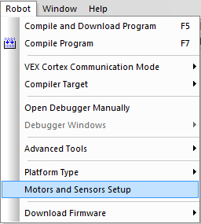
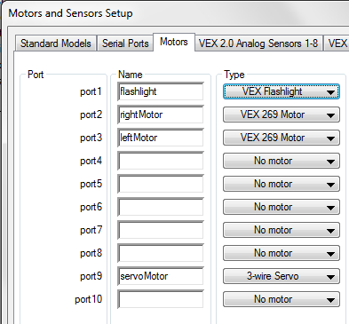
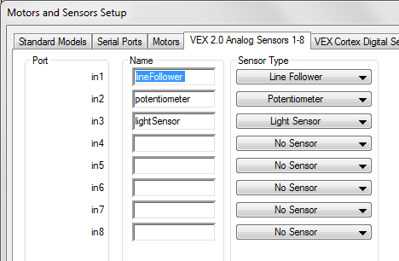
Analog Sensors Setup
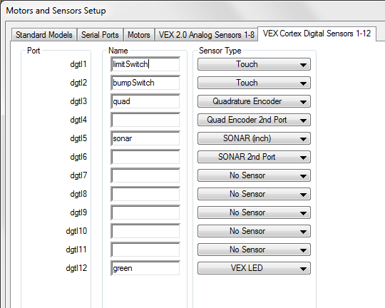
Digital Sensors Setup

- Obtain the teacher’s approval before proceeding to the next step.

Instructor’s Signature ______________________ Date __________

- Power on the Cortex.
- View motor and sensor debugger windows.
  - Click Robot.
  - Click Compile and Download Program. Leave the Program Debug window open.
  - Click Robot, Debug Windows, and then confirm that Motors has a check mark beside it. This indicates that it will be displayed in the Debug Window.
  - If there is not a Sensors tab available at the bottom of the window, add it using the following steps. Click Robot, Debug Windows, and then Sensors.
  - Increase the debugger window area at the bottom to view the motor and sensor values as shown below. Note that this window can be viewed any time by clicking Robot then Debugger.
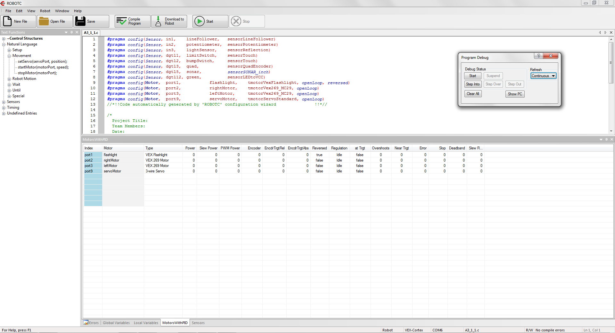
Motor and Sensor Windows

- Verify motor outputs.
  - Click the Motors tab at the bottom on the window.
  - Change the right motor value.
    - Click Port 2 under the Power column.
    - Enter several values ranging from -127 to 127, then press Enter on the keyboard or click away from the value entry window.
    - Record your observations in your engineering notebook, including the threshold power setting necessary for the motor to turn.
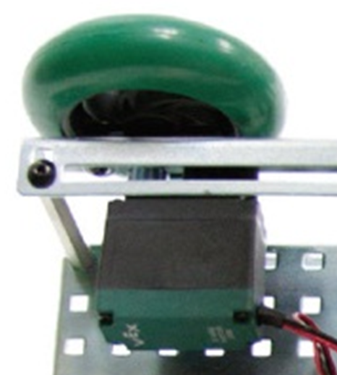
Motor

  - Change the left motor value.
    - Click Port 3 under the Power column.
    - Enter several values ranging from -127 to 127, and then press Enter on the keyboard or click away from the value entry window after each value is entered.
    - Record your observations in your engineering notebook, including the threshold power setting necessary for the motor to turn.
- Verify analog sensor inputs.
  - Click the Sensors tab.
  - In the Program Debug pop-up, ensure that inputs and outputs are being refreshed continuously. If not, choose “Continuous” from the Refresh drop-down menu.
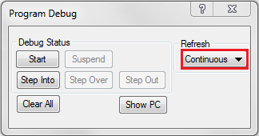
Continuous Option
  - Observe the line follower sensor.
    - View the value shown beside the lineFollower (in1) label.
    - Change the line follower immediate environment and observe the effect on the lineFollower value. Use a dark and light color within 1/4 - 1/8 in. to see the change in the sensor value.
    - Record your observations in your engineering notebook.
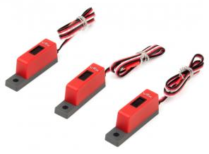
Line Follower

  - Observe the potentiometer.
    - View the value shown beside the potentiometer (in2) label.
    - Change the potentiometer setting and observe the effect on the potentiometer value. Rotate the potentiometer to change the sensor input. Do not force the potentiometer beyond the CW and CCW physical stops.
    - Record your observations in your engineering notebook.
    - Calculate the angle change between whole number values in your engineering notebook. Use the protractor below to measure an angle.
Potentiometer
Protractor

- Verify digital sensor inputs.
  - Verify that the Sensors tab is selected in the debugger window.
  - Observe the limit switch sensor.
    - View the value shown beside the limitSwitch (dgtl1) label.
    - Change the limit switch environment and observe the effect on the limitSwitch value. Your finger can be used to activate the limit switch.
    - Record your observations in your engineering notebook.
Limit Switch

  - Observe the bumper switch sensor.
    - View the value shown beside the bumpSwitch (dgtl2) label.
    - Change the bumper switch environment and observe the effect on the bumpSwitch value. Your finger can be used to activate the bumper switch.
    - Record your observations in your engineering notebook.
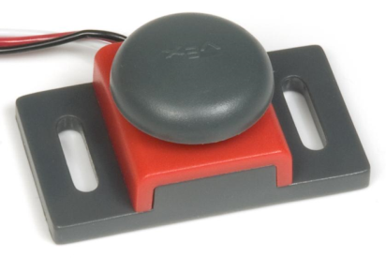
Bumper Switch
  - Observe the optical encoder sensor.
    - View the value shown beside the quad (dgtl3) label.
    - Change the optical encoder environment and observe the effect on the quad value. Rotate the optical encoder. Note that there is no CW or CCW physical stop; therefore, it can be turned indefinitely in either direction.
    - Record your observations in your engineering notebook.
Optical Encoder
  - Change the green LED light value.
    - Click the field beside green (dgtl12) under the Value column.
    - Enter a 0 value, and then press Enter on the keyboard or elsewhere in the dialog window. Did the LED respond as you expected?
    - Enter a 1 value, and then press Enter on the keyboard or click away from the value entry window. Did the LED respond as you expected?
    - Record your observations in your engineering notebook.
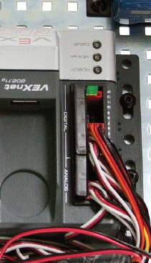
Green LED
- Obtain the teacher’s approval before proceeding to the next step.

Instructor’s Signature ______________________ Date __________

- Verify available output and inputs based on the testbed created.
Team A:
- Change the servo motor value.
    - Click Port 9 under the Power column.
    - Enter several values ranging from -127 to 127, then press Enter on the keyboard or click away from the value entry window.
    - Record your observations in your engineering notebook, including the servomotor physical range.
    - Calculate the angle change between whole number values in your engineering notebook. Use the protractor above to measure an angle.
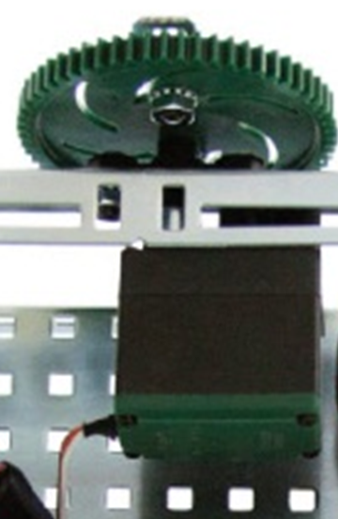
Servo Motor
- Change the flashlight value.
- Slide the physical switch on the flashlight to the on position.
- Click Port 1 under the Power column.
- Enter several values ranging from -127 to 127, then press Enter on the keyboard or click away from the value entry window. This allows the value to be updated. Note that the flashlight needs a negative value in the debugger window.
- Turn flashlight off.
- Record your observations in your engineering notebook.
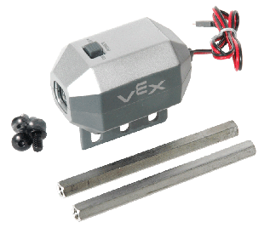
Flashlight

Team B:
- Observe the ultrasonic sensor.
- View the value shown beside the sonar (dgtl5) label.
- Change the ultrasonic environment with a solid object in front of the ultrasonic sensor. Observe the effect on the sonar value.
- Record your observations in your engineering notebook.
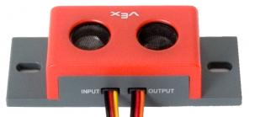
Ultrasonic

- Observe the light sensor.
- View the value shown beside the lightSensor (in3) label.
- Change the light sensor’s immediate environment by activating the flashlight and shining it on the light sensor. Use your hand to shield the light to the sensor to change the sensor input. Observe the effect on the lightSensor value.
- Record your observations in your engineering notebook.
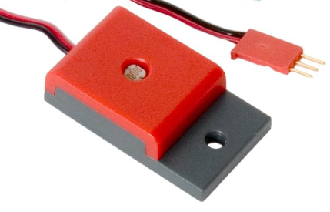
Light Sensor

- Exchange testbeds with the counterpart team within your group to explore the components present on the partner testbed.
- Repeat the step above with your testbed.
- Obtain the teacher’s approval upon completing this final step.

Instructor’s Signature ______________________ Date __________

Conclusion
- Describe how these motors and sensors may be used.

- Describe scenarios where the motors or sensors did not respond as you would predict.

