Activity 2.1.7 Calculating Truss Forces

Purpose
Because of the rigidity of a truss shape, it is not difficult to find the familiar triangles in many structures. Designers must accurately determine how much force occurs at locations of a truss design. The designer may change the material, the amount of material, or the number of members in a truss in order to make a design safer or more efficient. The calculations for determining truss forces are also a good basis for calculating forces for many other systems.

Equipment
- Straight edge
- Calculator

Procedure
In this activity you will make changes to given trusses to make them statically determinate. You will then solve for the outside forces and forces at each pinned connection of trusses.

Static Determinacy
It is important to know that a truss is statically determinate before attempting to solve for the internal forces. If the truss is statically indeterminate, then you will not be able to solve for all of the forces.

The trusses 1, 2, and 3 are statically indeterminate based on the formula 2J = M + R. Use the formula to demonstrate that each truss is statically indeterminate, then sketch a solution that would result in the truss being statically determinate. Remember when you sketch solutions that each should retain triangular shapes in order to remain rigid.
- J = Number of joints

- M = Number of members

- R = Number of reactions within a support | 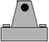 0r 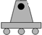

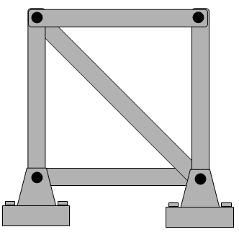

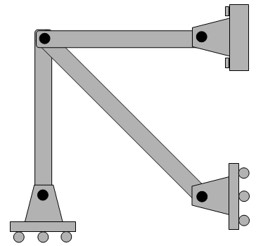

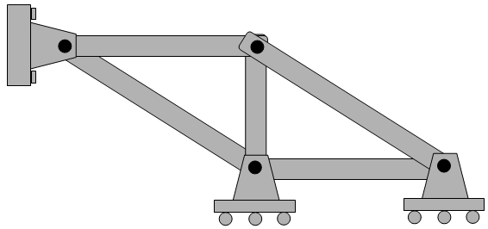

Solving Statically Determinate Trusses
Use the method below to calculate the forces occurring at each pinned connection.

- Draw a free body diagram of the entire truss. Label applied forces, known dimensions, and replace supports with labeled reaction forces.
- Sum the moments occurring about one or more pinned support(s) to solve for reaction forces at supports. There may be occasions when this will not solve any unknown reaction forces. If that happens, move to the next step.
- Use method of joints to create free body diagrams for each joint to solve for all of the forces acting at that joint. Precision (0.0).

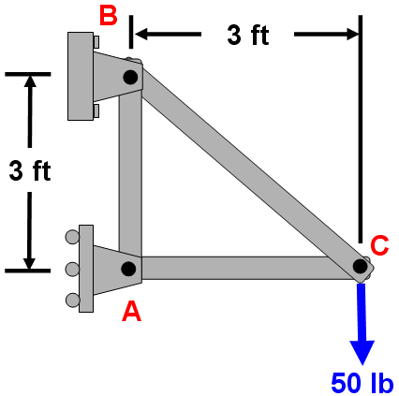

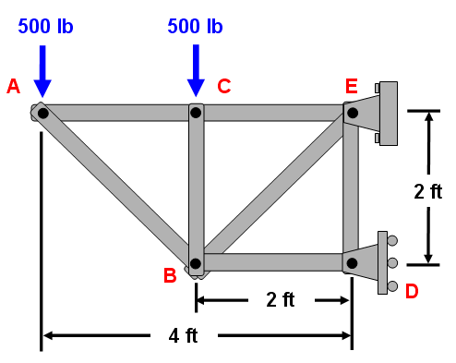

Conclusion
- What is the significance of including roller connections rather than pinned connections?

- How does the triangle shape make a truss rigid?

