Activity 2.1.6 Step-by-Step Truss System

Introduction
Truss systems are essential components within structural systems ranging from residential construction to large scale civil engineering projects such as bridges. Regardless of the system application, trusses are designed to utilize material strength, reduce costs, and support a determined load. Engineers must be able to understand how loads act on a truss structure and within the structure to ensure design feasibility and safety. Activity 2.1.6 will guide you through the step-by-step process of calculating reaction forces and member forces within a truss system.
Equipment
- Straight edge
- Calculator
- Pencil
Procedure
In this activity you will calculate reaction and member forces for the truss system illustrated below. It is essential to follow each step within the procedure to ensure proper calculations and free body diagrams.

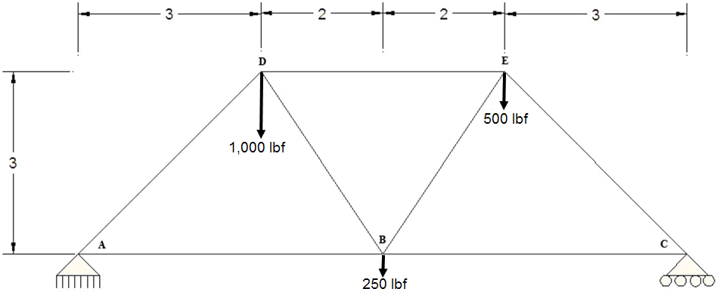

Calculate External Reaction Forces
x and y Reaction Force at Pin A and Y Reaction Force at Roller C
- Draw a free body diagram for the entire truss structure illustrated above.
Make sure to include all known and unknown angles, forces, and distances. Calculate and determine all angles using trigonometry and geometry.
(1 Box = .5 Units)
Hints:

sin θ = O/H
cos θ = A/H
tan θ = O/A

- Calculate reaction forces at the roller and pin connections.
  - List static equilibrium equations Hint: Σ.

  - List all known and unknown forces acting and reacting on the truss structure Label direction of force with an arrow.
    - Forces in the x-direction

    - Forces in the y-direction

    - Moment Forces – Determined from Pin A
Formula review:
M = Fd

  - Solve for R_{Cy} by using the moment static equilibrium equation acting upon pin A.
Equation |  | Substitution

 |  |  |  | R_{Cy}=
Simplification |  |  |  | Solution

  - Solve for unknown reaction force in the x-direction (R_{Ax}).
Use the sum of forces in the x-direction equilibrium equation.
 |  |  |  |  | R_{Ax}=
 | Equation |  | Substitution |  | Solution

  - Solve for unknown reaction forces in the y-direction.
Use the sum of forces in the y-direction equilibrium equation.
Equation |  | Substitution

R_{Ay}= .
Solution

  - Draw a free body diagram for the entire truss system illustrated on page 1.
Make sure to include your calculated support reactions (1Box = .5 units).

Calculate Individual Truss Member Forces
- Calculate AD and AB
  - Draw the free body diagram for joint A.
Make sure to include all known and unknown angles and forces (including x and y vector components). Do not include lengths.

  - Use SOH CAH TOA to express AD_{x} and AD_{y} in terms of AD.
    - Calculate AD_{x}
 |  |  |  | AD_{x} =
Equation |  | Substitution |  | Solution

    - Calculate AD_{y}
 |  |  |  | AD_{y} =
Equation |  | Substitution |  | Solution

  - List all known and unknown forces.
Label direction of force with an arrow.
    - Forces in the x-direction

    - Forces in the y-direction

  - Use static equilibrium equations to solve for AD and AB.
    - Solve for AD by calculating y-direction static equilibrium.
Equation |  | Substitution |  | Simplification

 |  |  |  | AD =
 |  | Simplification |  | Solution

    - Solve for AB by calculating x-direction static equilibrium.
Equation |  | Substitution |  | Simplification

 |  |  |  | AB =
 |  | Substitution – Insert calculated FAD value |  | Solution

  - Update the joint A free body diagram with calculated forces for AD and AB.

- Calculate CB and CE.
  - Draw the free body diagram for joint C.
Make sure to include all known and unknown angles and forces (including x and y vector components). Do not include lengths.

  - Use SOH CAH TOA to express CE_{x} and CE_{y} in terms of CE.
    - Calculate CE_{x}
 |  |  |  | CE_{X} =
Equation |  | Substitution |  | Solution

    - Calculate CE_{y}
 |  |  |  | CE_{y} =
Equation |  | Substitution |  | Solution

  - List all know and unknown forces.
Label direction of force with an arrow.
    - Forces in the x-direction

    - Forces in the y-direction

  - Use static equilibrium equations to solve for AD and AB.
    - Solve for CE by calculating y-direction static equilibrium.
Equation |  | Substitution |  | Simplification

CE =
Solution

    - Solve for CB by calculating x-direction static equilibrium.
Equation |  | Substitution |  | Simplification

 |  |  |  | CB =
 |  | Substitution – Insert calculated CE value |  | Solution

  - Update joint C free-body diagram with calculated forces for CE and CB.

- Calculate EB and ED
  - Draw the free-body diagram for joint E.
Make sure to include all known and unknown angles and forces (including x and y vector components). Do not include lengths.

  - Use SOH CAH TOA to express EB_{x} and EB_{y} in terms of EB.
    - Calculate EB_{y}
 |  |  |  | EB_{y} =
Equation |  | Substitution |  | Solution

    - Calculate EB_{x}
 |  |  |  | EB_{x} =
Equation |  | Substitution |  | Solution

  - List all known and unknown forces.
Label direction of force with an arrow.
    - Forces in the x-direction

    - Forces in the y-direction

  - Use static equilibrium equations to solve for EB.
    - Calculate y-direction static equilibrium.
Equation |  | Substitution |  | Simplification

 |  |  |  | EB =
Substitution |  | Simplification |  | Solution

    - Calculate x-direction static equilibrium.
Equation |  | Substitution |  | Simplification

 |  |  |  | ED =
Substitution |  | Simplification |  | Solution
  - Update joint E free body diagram with calculated forces for EB and ED.

- Calculate DB
  - Draw the free body diagram for joint D.
Make sure to include all known and unknown angles and forces (including x and y vector components). Do not include lengths.

  - Use SOH CAH TOA to express DB_{x} and DB_{y} in terms of DB.
    - Calculate DB_{y}
 |  |  |  | DB_{y} =
Equation |  | Substitution |  | Solution

    - Calculate DB_{x}
 |  |  |  | DB_{x} =
Equation |  | Substitution |  | Solution

  - List all known and unknown forces.
Label direction of force with an arrow.
    - Forces in the x-direction

    - Forces in the y-direction

  - Use static equilibrium equations to solve for DB.
    - Solve for DB by calculating y-direction static equilibrium.
Equation |  | Substitution |  | Simplification

 |  |  |  | DB =
 |  | Simplification |  | Solution

  - Update joint D free body diagram with calculated forces for DB and DE.
Draw Completed Free Body Diagram
- Draw a completed free body diagram for entire truss structure using all calculated reaction and member forces.

